10

Managing Desired State Configuration

In this chapter, we cover the following recipes:

* Using DSC and built-in DSC resources
* Parameterizing the DSC configuration
* Finding and installing DSC resources
* Using DSC with resources from PS Gallery
* Configuring the DSC local configuration manager
* Implementing an SMB DSC pull server
* Implementing a web-based DSC pull server
* Using DSC partial configurations

# Introduction

Desired State Configuration (DSC) is a management platform within Windows Server, and is implemented with Windows PowerShell. DSC enables you to define a computer's desired state declaratively and have PowerShell ensure that the computer is configured accordingly, and that it remains so. This is simpler than writing complex scripts to configure a particular computer.

With DSC, you define a configuration that describes the details of how a given node (computer) is to be configured. The configuration defines a series of resources to be invoked on the node and how these resources should be configured.

A DSC resource is a PowerShell module that is instructed to configure a given object residing on a node. If you are planning on using a specific DSC resource, you need the related PowerShell module on the computer on which you author the DSC configurations and on the target node.

As an example, you could define a node and specify that the WindowsFeature resource should be configured to ensure that the Web-Server feature (a subset of the full installation of Internet Information Service (IIS)) is installed. You could also use the DSC File resource to ensure that a set of files—which are available from somewhere in your network or the internet—are present on the target node. This could dramatically simplify the process of configuring a web farm and ensure that it stays configured properly.

Resources come from a variety of sources. Microsoft has a few resources built in to PowerShell, and these ship inside Windows Server 2019. But you can also get additional DSC resources from the internet, or you can develop your own DSC resources. For more information on developing DSC resources, refer to <https://docs.microsoft.com/powershell/dsc/resources/authoringResource>.

Note

PowerShell V6 and later versions do not currently support DSC. If you want to leverage DSC, you are going to need to use PowerShell V4 or later versions (preferably PowerShell version 5.1).

The first step with DSC is defining a configuration statement. A configuration statement, which is not dissimilar to a function, defines the desired state of a node. It states how you wish certain resources on the target node to be configured.

The next step is to execute the configuration statement. This is a lot like functions in PowerShell. When you execute your function, you are compiling it and creating a managed object format (MOF) file as output.

You can parameterize configuration statements to make it simple to create different MOF files based on the parameter values. For example, a configuration statement could take a node name and the name of a Windows feature that should be present on the node. When you run the configuration, you specify values for the node name (for example, DC1), and the name of the Windows feature you want loaded (for example, Web-Server). The generated MOF file instructs DSC to ensure that the Web-Server feature is present on DC1.

When you run the configuration statement, PowerShell compiles the DSC configuration into a PowerShell function. When you invoke this generated function, PowerShell creates a MOF file based on the specified configuration. A MOF file tells PowerShell precisely how the resource is to be configured on a specific node.

Microsoft chose to use the MOF file in addition to the configuration statement to define the configuration. MOF is standardized and well supported, although it is more complex in terms of syntax and content. Separating the specification of the configuration from the details involved in deploying it can feel like additional overhead (create the PowerShell configuration statement, then create and deploy the MOF file).

Microsoft thought that someone could create a DSC-workbench-type product that enabled you to use a GUI and define the configuration graphically. Then, at the click of a button, this as-yet unbuilt tool would generate the necessary MOF file and deploy it automatically. Even though this GUI has never been built, the approach does allow you to define security boundaries between defining a configuration and deploying it.

Once you have generated the MOF files, you deploy the configuration. DSC uses the MOF file to ensure that the specified DSC resources are correctly configured on the target node. Subsequently, you can check that the node is correctly configured, with the service and files in place, and remedy any unapproved changes to the target node, referred to as configuration drift.

You can also use DSC to have a node pull configuration details from a centralized pull server. The pull server is a server that makes DSC configuration files (that is, the MOF files) and the resources available to target nodes. A target node is set up to regularly contact the pull server and pull configuration information (and any required resources) from the pull server. You can have two types of pull server—a web pull server or an SMB pull server. The latter is simpler to set up.

With a pull server, you configure the target node's local configuration manager (LCM) with a GUID and the location of the pull server. The LCM uses that GUID to locate the configuration information that you want to be applied to the node on the pull server. This enables you to configure multiple servers—for example a multinode web farm—identically by just giving them the same GUID.

A DSC partial configuration is a configuration statement that defines part of a node's overall configuration. This enables you to combine different configuration statements and have DSC add them together as it configures the node. In larger organizations, different teams can determine a part of a node's configuration independently. Partial configurations allow you to deploy the partial configurations from the different teams to the relevant nodes.

In this chapter, you first look at the built-in resources and the basics of DSC deployment. Then you learn how to get more resources, how to set up a pull server, and finally, how to implement partial configurations.

# Using DSC and built-in resources

This recipe shows you how to use DSC in push mode. With this mode, you create a configuration document on one system—in this case SRV1—and push the configuration to the target node (SRV2). You can also use DSC in pull mode, which you look at in greater detail in the Implementing an SMB DSC pull server and Implementing a web-based DSC pull server recipes.

With pull mode, you create a configuration definition and execute it to produce a MOF file. In this recipe, you use the built-in File resource to specify the files that should be on the target node (and where to find them if they are not).

## Getting ready

In this recipe, you examine the Windows Server 2019 built-in resources and use these to create and compile a configuration statement on server SRV1. You use this configuration statement to then deploy the Web-Server feature on a second server, SRV2.

This recipe relies on two files being created and shared from DC1. The two files are Index.Htm and Page2.Htm. These two files are created and shared as \\DC1\ReskitApp. You can use the following code to achieve this, which you can run on SRV1:

# Setup for DSC Recipe

# Create folder/share on DC1

$SB = {

New-Item C:\ReskitApp -ItemType Directory

New-SMBShare -Name ReskitApp -Path C:\ReskitApp

}

Invoke-Command -ComputerName DC1 -ScriptBlock $SB |

Out-Null

# Create Index.Htm on DC1

$HP = '\\DC1.Reskit.Org\C$\ReskitApp\Index.htm'

$P2 = '\\DC1.Reskit.Org\C$\ReskitApp\Page2.htm'

$Index = @"

<!DOCTYPE html>

<html><head><title>

Main Page - ReskitApp Application</title></head>

<body><p><center><b>

HOME PAGE FOR RESKITAPP APPLICATION</b></p>

This is the root page of the RESKITAPP application

<br><hr>

Pushed via DSC</p><br><hr>

<a href="http://SRV2/ReskitApp/Page2.htm">

Click to View Page 2</a>

</center>

<br><hr></body></html>

"@

$Index |

Out-File -FilePath $HP -Force

# Create Page2.htm on DC1

$Page2 = @"

<!DOCTYPE html>

<html>

<head><title>ReskitApp Application - Page 2</title></head>

<body><p><center>

<b>Page 2 For the ReskitApp Web Application</b></p>

<a href="http://SRV2/ReskitApp/Index.htm">

Click to Go Home</a>

<hr></body></html>

"@

$Page2 |

Out-File -FilePath $P2 -Force

You can use (and embellish) this code and HTML. Alternatively, the GitHub repository supporting this book has both of these files, which you can download. See <https://github.com/doctordns/PowerShellCookBook2019/tree/master/Chapter%2010%20-%20Implementing%20Desired%20State%20Configuration> for the HTML for these two pages, and for this script, see <https://github.com/doctordns/PowerShellCookBook2019/blob/master/Chapter%2010%20-%20Implementing%20Desired%20State%20Configuration/Setup-DSCWebApp.ps1>.

Note

The recipe just uses DSC to ensure that these two files reside on SRV2, and if they do not, they are copied from the share on DC1. This recipe does not create a web server on SRV2 or create a website using these two files.

You run this recipe on SRV1.

## How to do it…

1. Discover DSC resources on SRV1 using the following code:

Get-DscResource |

Format-Table -Property Name, ModuleName, Version

1. Examine the DSC File resource using the following code:

Get-DscResource -Name File |

Format-List -Property *

1. Get the DSC File resource syntax using the following code:

Get-DscResource -Name File -Syntax

1. Create/compile a configuration block using the following code:

Configuration PrepareSRV2 {

Import-DscResource –ModuleName 'PSDesiredStateConfiguration'

Node SRV2

{

File BaseFiles

{

DestinationPath = 'C:\ReskitApp\'

SourcePath = '\\DC1\ReskitApp\'

Ensure = 'Present'

Recurse = $True

}

}

}

1. View the configuration function using the following code:

Get-Item -Path Function:\PrepareSRV2

1. Create an output folder for DSC using the following code:

$Conf = {

$EASC = @{ErrorAction = 'SilentlyContinue'}

New-Item -Path C:\ReskitApp -ItemType Directory @EASC

}

Invoke-command -ComputerName SRV2 -ScriptBlock $Conf |

Out-Null

1. Run the following function to produce a MOF file:

PrepareSRV2 -OutputPath C:\DSC

1. View the MOF file, as follows:

Get-Content -Path C:\DSC\SRV2.mof

1. Make it so, Mr. Riker!

Start-DscConfiguration -Path C:\DSC -Wait -Verbose

1. Observe the results using the following code:

Get-ChildItem -Path '\\SRV2\C$\ReskitApp'

1. Induce a configuration drift using the following code:

Remove-Item -Path \\SRV2\C$\ReskitApp\Index.htm

1. Fix the configuration drift using the following code:

Start-DscConfiguration -Path C:\DSC\ -Wait -Verbose

1. What happens if there is no configuration drift?

Start-DscConfiguration -Path C:\dsc\ -Wait -Verbose

## How it works...

In step 1, you discover the DSC resources on SRV1, which looks like this:

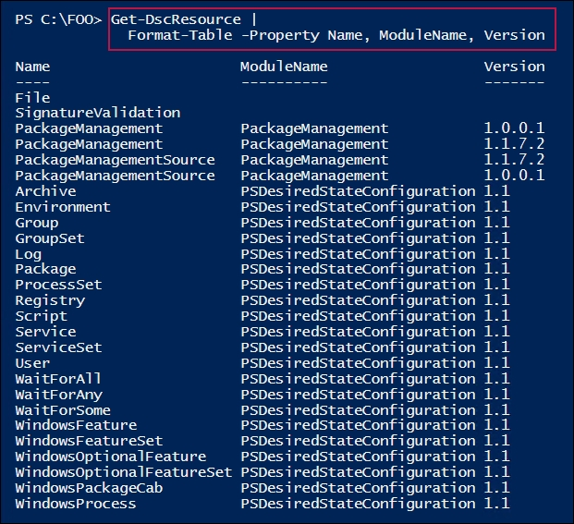

In step 2, you use the Get-DSCResource to discover more information about the in-built file DSC resource. The output from this step is shown in the following screenshot:

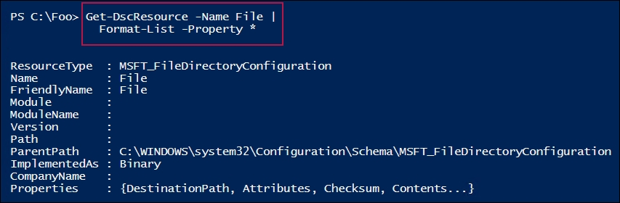

In step 3, you use the Get-DSCResouce cmdlet to determine the syntax for the File DSC resource, as follows:

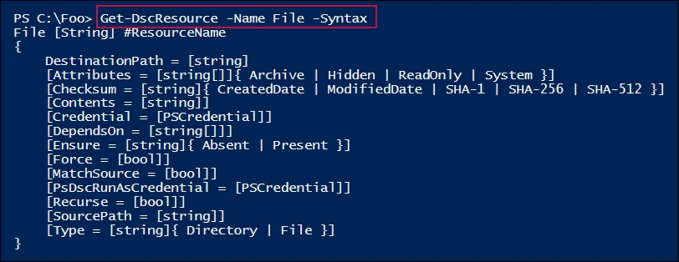

In step 4, you define a configuration block. When you execute this configuration block, PowerShell compiles it into a function. There is no output from this step.

In step 5, you view the function definition for this compiled configuration block, which looks like this:

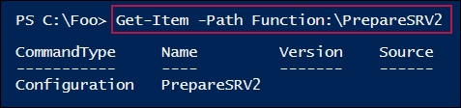

In step 6, you create a folder on SRV2. This folder is where you want the DSC process to place the files specified in the configuration block. There is no output from this step.

In step 7, you execute the PrepareSRV2 function, which creates a MOF file corresponding to the configuration. The output looks like this:

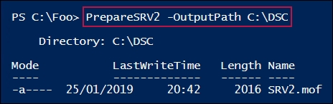

In step 8, you view the MOF file that PowerShell generated in step 7, which looks like this:

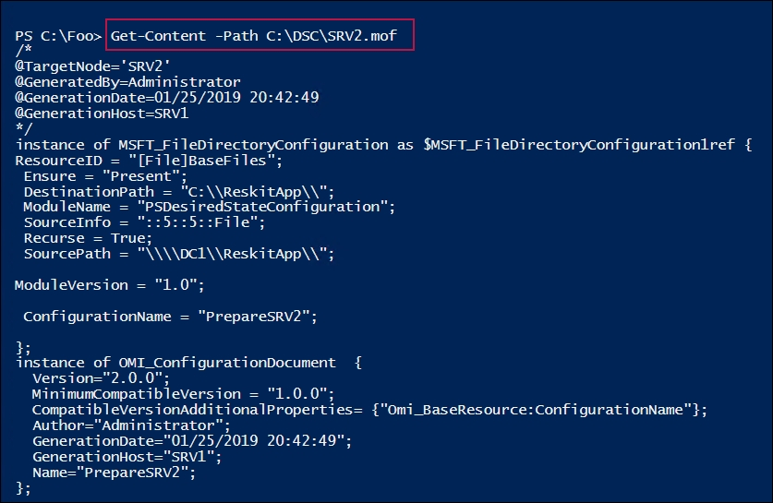

In step 9, you push the DSC configuration to SRV2. You use the -Wait and -Verbose switches to create rich output, which looks like this:

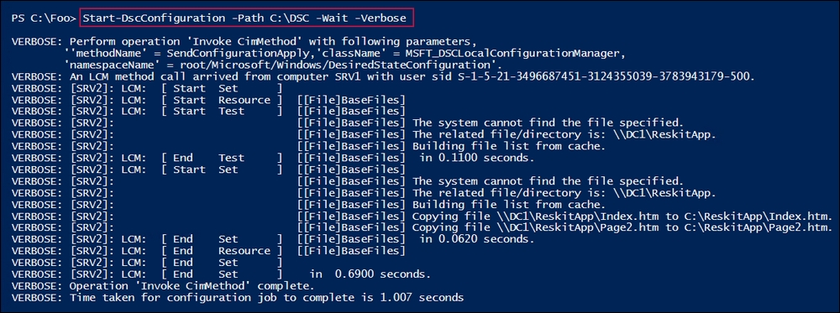

After pushing the new configuration to SRV2 in step 9 and step 10, you examine the effect. The output from this step looks like this:

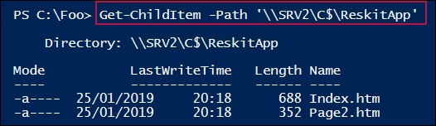

In step 11, you delete a file on SRV2, thereby introducing configuration drift. This step produces no output. With step 12, you rerun Start-DSCConfiguration to correct the configuration drift, which looks this:

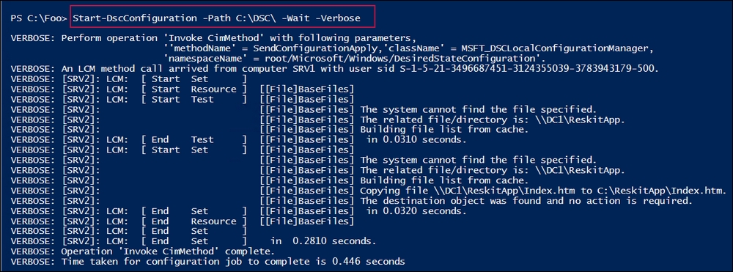

In step 13, you observe the results of running Start-DSCResource in the case where there is no configuration drift. This looks like the following:

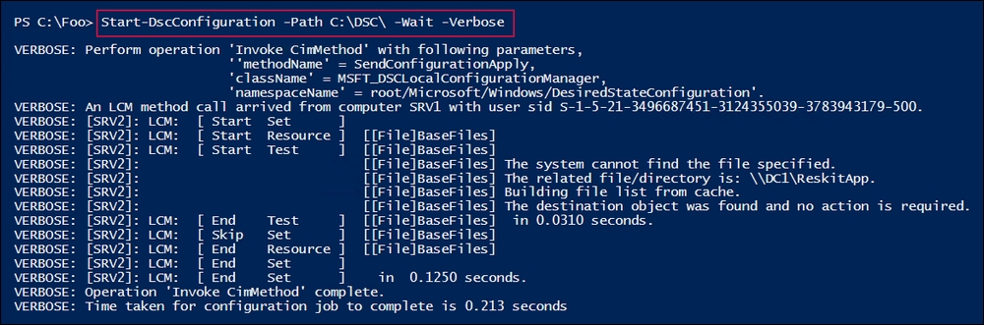

## There's more...

In this recipe, you push the DSC configuration to the target node (SRV2) using the Start-DscConfiguration cmdlet. Using the -Wait and -Verbose switches produces some great output that helps you to trace precisely what DSC is doing. In step 9, DSC could not find the files on SRV2, and so it copies them from DC1. In step 12, DSC discovers a missing file and corrects that.

With Start-DscConfiguration, if you do not specify the -Wait switch, PowerShell runs the DSC configuration silently as a background job. If you do not specify the -Verbose switch specified, PowerShell produces minimal output. You should use both parameters when you are learning DSC.

In step 1, you discover the DSC resources on SRV1. As you can see, there are not many built into Windows Server 2019. The good news is that there is a wealth of additional DSC resources that you can leverage, as you can see in the Using DSC with resources from the PS Gallery recipe.

In step 4, when you execute the configuration block, PowerShell compiles in a similar way to how PowerShell compiles a function. With configurations, PowerShell creates a function of the same name, as you can see in step 5.

In step 8, you view the MOF generated by running the function created by running the configuration. Fortunately, IT pros do not need to understand the MOF file format as it is automatically generated by PowerShell. Further, PowerShell uses the MOF file to apply the DSC configuration on the target node. All you need to do is to keep track of the MOF files themselves.

# Parameterizing DSC configuration

As with functions, you can create configuration blocks with parameters. These enable you to produce different MOF files by varying the parameter values that are used when you execute the configuration.

For example, suppose you wanted to add a feature to a node. You could create a specific configuration where you hard code the feature name and the node name. This is not dissimilar to how you copied specific files from DC1 to SRV1 in the Using DSC and built-in resources recipe.

With parameterization, you create a configuration that takes the node name and the service name as parameters. When you run the configuration, PowerShell creates a MOF file that adds the specified service to the specified node. This recipe demonstrates that approach.

This approach throws up the problem that, by default, you can only send a single MOF file to a given node; therefore, if you used the earlier recipe and copied files to SRV2, attempting to send a second MOF file to the system results in an error. There are three solutions to this, as described in the following list:

* Have a single MOF file generated for each target node. This means larger MOF files, and files that are used for larger organizations sometimes require hard-to-achieve coordination between the different groups that create the overall configuration for a node.
* Use DSC partial configurations, which enables you to send multiple configurations to a node. You configure the node to pull different configuration blocks from potentially multiple DSC pull servers, and then the DSC's local configuration manager combines and then applies them. The Using DSC partial configuration recipe shows you how to use partial configurations.
* Push a configuration to a node, remove the node's MOF files, and send another configuration. This recipe demonstrates this—you remove the MOF files on SRV2 that DSC created when you pushed the configuration. By removing the files from the node, DSC is happy to apply another configuration.

## Getting ready

This recipe uses SRV1 and SRV2, as configured in the Using DSC and built-in resources recipe.

## How to do it…

1. Check the status of DNS on SRV2 using the following code:

Get-WindowsFeature DNS -ComputerName SRV2

1. Create a configuration document using the following code:

Configuration ProvisionServices

{

param (

[Parameter(Mandatory=$true)] $NodeName,

[Parameter(Mandatory=$true)] $FeatureName

)

Import-DscResource –ModuleName 'PSDesiredStateConfiguration'

Node $NodeName {

WindowsFeature $FeatureName {

Name = $FeatureName

Ensure = 'Present'

IncludeAllSubFeature = $true

} # End Windows Feature

} # End Node configuration

} # End of Configuration document

1. Ensure that an empty DSC folder exists, then create MOF file using the following code:

$NIHT = @{

Path = 'C:\DSC '

ItemType = 'Directory'

ErrorAction = 'SilentlyContinue'

}

New-Item @NIHT| Out-Null

Get-ChildItem -Path C:\DSC | Remove-Item -Force | Out-Null

1. Clear any existing configuration documents on SRV2 using the following code:

$RIHT =@{

Path = '\\SRV2\C$\Windows\System32\configuration\*.mof'

ErrorAction = 'SilentlyContinue'

}

Get-Childitem '\\SRV2\C$\Windows\System32\configuration\*.MOF' |

Remove-Item @RIHT -Force

1. Now run the ProvisionServices function to create the MOF to provision DNS on SRV2, using the following code:

$PSHT = @{

OutputPath = 'C:\DSC'

NodeName = 'SRV2'

FeatureName = 'DNS'

}

ProvisionServices @PSHT

1. And make it so:

Start-DscConfiguration -Path C:\DSC -Wait -Verbose

1. Check the results on SRV2 using the following code:

Get-Service -Name DNS -ComputerName SRV2

## How it works...

In step 1, you check to see whether the DNS server service is installed on SRV2. The output showing that DNS is not installed looks like this:

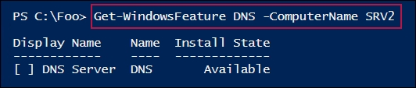

In step 2, you create a parameterized configuration (ProvisionServices) that takes a feature name and a node name as parameters. In step 3, you ensure that C:\DSC is created on SRV1 and is empty (that is, with no MOF files left over from earlier recipes!). In step 4, you clear out any MOF files on SRV2. These steps produce no output.

In step 5, you create a MOF file, specifying the name of the feature (DNS) you wish to install on the node (SRV2). The output looks like this:

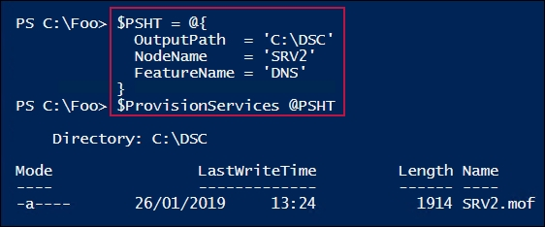

In step 6, you use Start-DscConfiguration to push the configuration to SRV2, which looks like this:

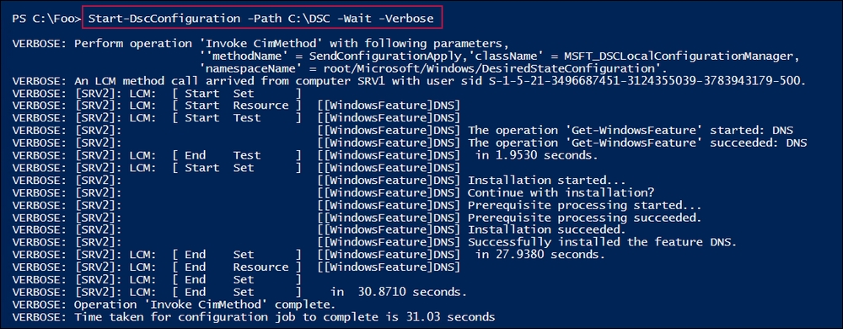

In the final step, step 7, you recheck the DNS Server service on SRV2 to find out whether it is installed and running, which looks like this:

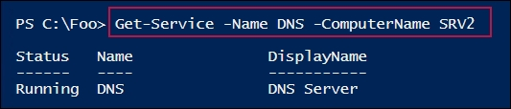

## There's more...

In step 2, you create a simple parameterized configuration statement. This configuration takes two parameters: a feature name and a node name. The purpose of the configuration block is to add a named feature (for example, DNS) to a named node (SRV2). With this configuration, you can create the necessary MOF file to add any feature to any node.

In step 4, you clear any previously created MOF files from SRV2. If you delete a previously pushed MOF file, the configuration set by those configuration MOF files does not change. This enables you to use SRV2 to test different configurations or multiple DSC recipes.

# Finding and installing DSC resources

A DSC resource is a specially crafted PowerShell module that enables DSC to configure various aspects of a node. The WindowsFeature DSC resource, for example, enables you to ensure that a particular node has a particular Windows feature installed. You can also specify that a particular Windows feature should not be present (in which case, DSC removes the feature if it were already installed).

As you saw in the Using DSC and built-in resources recipe, Microsoft does not ship very many DSC resources natively with Windows Server 2019. This is intentional—you use the PowerShell Gallery to get the DSC resources you need to do your job and not hundreds or thousands of DSC resources you never need.

The built-in DSC resources with Windows Server 2019 do not provide broad coverage, and are not sufficient for most organizations. For example, you can use the built-in File resource to copy the source files for a small web application onto a new server, as you did in the Using DSC and built-in resources recipe. But the built-in resources do not allow you to specify the application's settings (what the application's name is, which application pool it runs in, and so on). This is where add-on DSC resources from the PS Gallery come in.

In this recipe, you use the PS Gallery to find, install, and explore third-party DSC resources. In the next recipe, Using DSC with resources from PS Gallery, you use the newly installed resources.

## Getting ready

In this recipe, you find, download, and install DSC resources.

## How to do it…

1. Find available repositories using the following code:

Get-PSRepository

1. See what DSC resources you can find using the following code:

Find-DscResource -Repository 'PSGallery' |

Measure-Object

1. See what IIS-related resources might exist using the following code:

Find-DscResource |

Where-Object ModuleName -match 'web|iis' |

Select-Object -Property ModuleName, Version -Unique |

Sort-Object -Property ModuleName

1. Examine the xWebAdministration module using the following code:

Find-DscResource -ModuleName 'xWebAdministration'

1. Install the xWebAdministration module (on SRV1) using the following code:

Install-Module -Name 'xWebAdministration' -Force

1. See the local module details using the following code:

Get-Module -Name xWebAdministration -ListAvailable

1. See what DSC resources are contained in the module using the following code:

Get-DscResource -Module xWebAdministration

1. Examine what is in the module using the following code:

$Mod = Get-Module -Name xWebAdministration -ListAvailable

$P = $Mod.Path

$FP = Split-Path -Parent $P

Get-ChildItem -Path $FP, $FP\DSCResources

## How it works...

In step 1, you examine any configured repositories on your system. Depending on the recipes you have performed on SRV1, the output of this step looks like this:

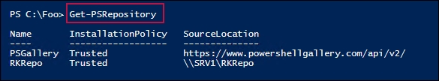

In step 2, you use the Find-DSCResource cmdlet to examine how many DSC resources are in the gallery (at the time of writing!), which looks like this:

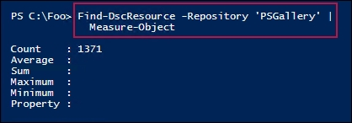

In step 3, you query the PS Gallery to find DSC resources that might be helpful to manage IIS. The output looks like this:

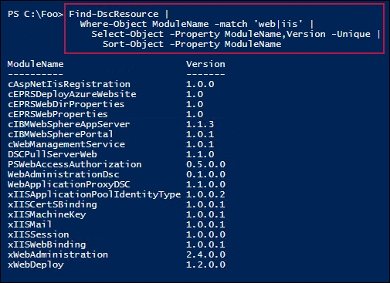

In step 4, you look at the DSC resources in the xWebAdministration module on the PS Gallery. The output looks like this:

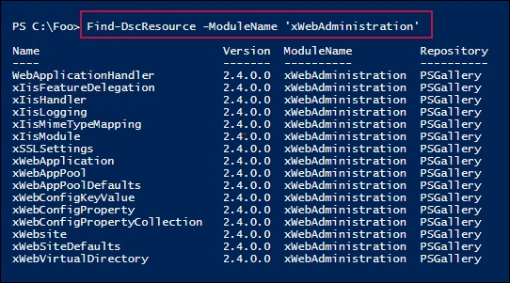

In step 5, you install the module on SRV1. This step produces no output. In step 6, you examine the details of the newly installed module, which looks like this:

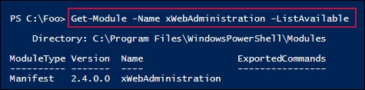

In step 7, you use the Get-DscResource cmdlet to discover the specific DSC resources contained in the xWebAdministration module, which looks like this:

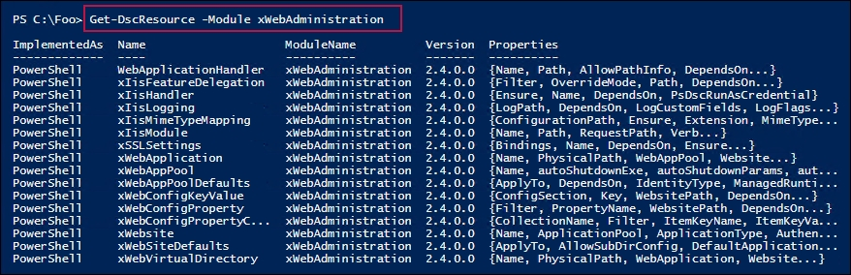

In the last step, step 8, you view the files that make up the xWebAdministration module. The output looks like this:

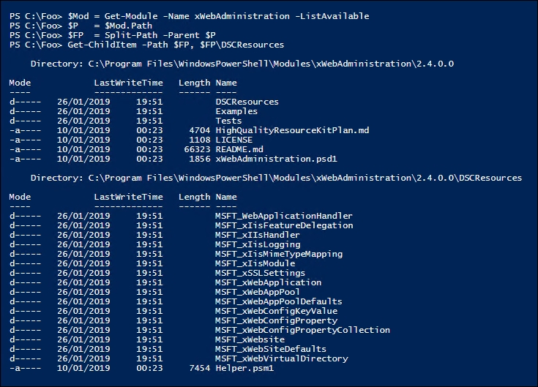

## There's more...

This recipe describes how to obtain DSC resources from the PowerShell Gallery repository, but there are many other places that you can find DSC resources. One other repository you might consider is Chocolatey (<https://www.chocolatey.org>).

In step 3, you query the PS Gallery to discover DSC resources that might be useful. In this step, you find any DSC resource whose name contains either web or iis. Depending on what DSC resource you are looking for, you may need to adjust this regular expression string.

In step 8, you view the files that make up the xWebAdministration module. To learn more about how to develop DSC resources, you should examine the files in this module in more detail.

## See also

In step 8, you examine the files making up the xWebAdministration module. For more information about what is inside a DSC resource module, see <https://docs.microsoft.com/powershell/dsc/resources/resources>.

If you cannot find the DSC resources you need, you can always create your own customized resources. There are two main methods that IT pros can use to write their own resources. You can use the traditional approach, where you both write the PowerShell code and create a MOF schema. With PowerShell 5, Microsoft introduced a much simpler method of creating a DSC resource based on PowerShell classes. For more details about the older mechanism, see <https://docs.microsoft.com/powershell/dsc/resources/authoringresourcemof>, and for more details about creating a DSC resource using PowerShell classes, see <https://docs.microsoft.com/powershell/dsc/resources/authoringresourceclass>. And finally, for the hard core folks, you can implement the resource in C# (<https://docs.microsoft.com/powershell/dsc/resources/authoringresourcemofcs>).

If you do decide to develop your own DSC resources, take a look at using the Resource Designer tool—a set of cmdlets that make creating DSC resources easier. See <https://docs.microsoft.com/powershell/dsc/resources/authoringresourcemofdesigner> for more details about this tool.

# Using DSC with resources from PS Gallery

In the Finding and installing DSC resources recipe, you discovered and installed some additional DSC resources. The xWebAdministration module you installed contains a number of DSC resources that enable you to define the configuration of an IIS website.

In this recipe, you are going to make use of this module to create, configure, and view a new website on SRV2, based on the files created in the Using DSC and built-in resources recipe. This recipe uses the DSC resources contained in the xWebAdministration module (which you downloaded in the Finding and installing DSC resources recipe).

## Getting ready

In this recipe, you use SRV1 to manage DSC resources and configurations, SRV2 as the target node that DSC is going to control, and DC1 as both the DC in the domain and the source of the initial files that make up the application you deploy. You run this recipe on SRV1.

## How to do it…

1. Copy the xWebAdministration module to SRV2 using the following code:

$CIHT = @{

Path = 'C:\Program Files\WindowsPowerShell\' +

'Modules\xWebAdministration'

Destination = '\\SRV2\C$\Program Files\WindowsPowerShell\'+

'Modules'

Recurse = $True

}

Copy-Item @CIHT

1. Clear any existing configuration documents on SRV2 and local MOF files on SRV1 using the following code:

$RIHT =@{

Path = '\\SRV2\C$\Windows\System32\configuration\*.mof'

ErrorAction = 'SilentlyContinue'

}

Get-Childitem @RIHT |

Remove-Item @RIHT -Force

Remove-Item C:\DSC\* -Recurse -Force

1. Create a new configuration document based on DSC resources in the xWebAdministration module using the following code:

Configuration RKAppSRV2 {

Import-DscResource -ModuleName xWebAdministration

Import-DscResource -ModuleName PSDesiredStateConfiguration

Node SRV2 {

Windowsfeature IISSRV2 {

Ensure = 'Present'

Name = 'Web-Server'

}

Windowsfeature IISSrvTools {

Ensure = 'Present'

Name = 'Web-Mgmt-Tools'

DependsOn = '[WindowsFeature]IISSRV2'

}

File RKAppFiles {

Ensure = 'Present'

Checksum = 'ModifiedDate'

Sourcepath = '\\DC1\ReskitApp\'

Type = 'Directory'

Recurse = $true

DestinationPath = 'C:\ReskitApp\'

DependsOn = '[Windowsfeature]IISSRV2'

MatchSource = $true

}

xWebAppPool ReskitAppPool {

Name = 'RKAppPool'

Ensure = 'Present'

State = 'Started'

DependsOn = '[File]RKAppFiles'

}

xWebApplication ReskitAppPool {

Website = 'Default Web Site'

WebAppPool = 'RKAppPool'

Name = 'ReskitApp'

PhysicalPath = 'C:\ReskitApp\'

Ensure = 'Present'

DependsOn = '[xWebAppPool]ReskitAppPool'

}

Log Completed {

Message = 'Finished Configuring ReskitAp via DSC'

}

} # End of SRV2 Configuration

} # End of Configuration

1. Run the configuration block to compile it to C:\DSC on SRV1 using the following code:

RKAppSRV2 -OutputPath C:\DSC

1. Deploy the configuration to SRV2 using the following code:

Start-DscConfiguration -Path C:\DSC -Verbose -Wait

1. Test the result using the following code:

Start-Process 'HTTP://SRV2.Reskit.Org/ReskitApp/'

## How it works...

In step 1, you copy the xAdministration module to SRV2, then in step 2, you clear out any MOF files on SRV2 and SRV1. These two steps produce no output.

In step 3, you create a configuration document, RKAppSRV2. This step also produces no screen output.

In step 4, you create the MOF file for this recipe by executing the RKAppSRV2 function, which should yield the output shown in the following screenshot:

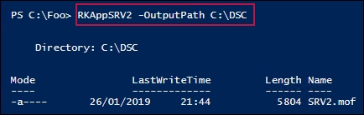

In step 5, you deploy this new configuration to SRV2 using the -Wait and -Verbose switches, producing an output like the following:

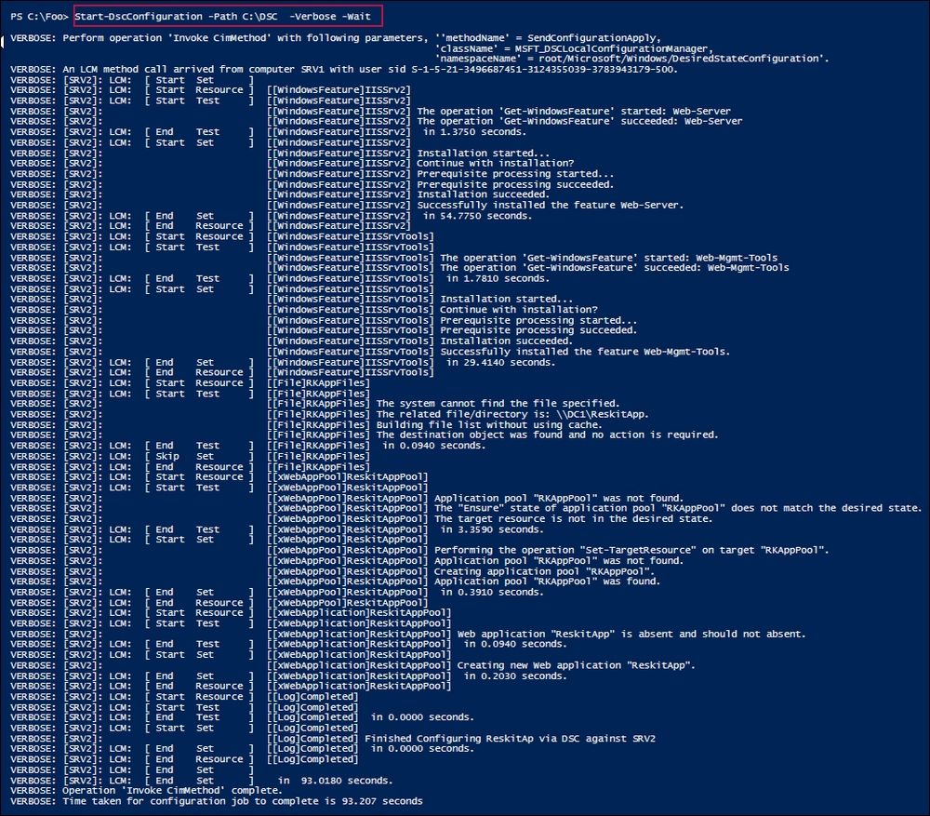

Finally, in step 6, you view the web pages created by the earlier steps. If you first navigate to the home page of the application, using step 6. You should see the following:

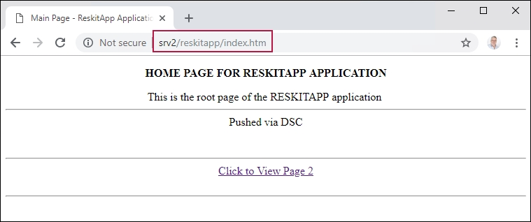

From this page, if you click to page 2, you should see this:

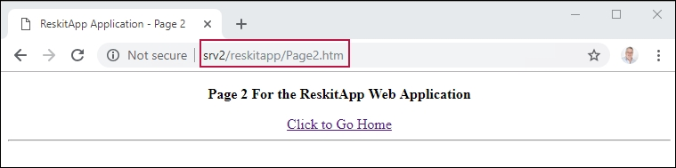

## There's more...

In step 3, you created a configuration block that does the following:

* Configures SRV2 with two Windows features (Web-Server and Web-Mgmt-Tools)
* Copies the application's source files from DC1 to SRV2
* Creates an application pool, RKAppPool
* Creates an IIS web application, ReskitApp

This step also demonstrates the dependency mechanism in DSC. A dependency allows you to state that a particular resource configuration can only be performed after some other resource configuration has completed. For example, this configuration does not create a ReskitApp application until the RKAppPool application pool exists and does not do either until the WindowsFeature resource has finished installing IIS.

This recipe uses the push model for DSC deployment. In this recipe, you manually copy the xWebAdministration module to SRV2 as part of the recipe. If you use a pull server model to deploy DSC, target nodes can download the necessary resources from the pull server, which greatly simplifies deployment of DSC resources. The two recipes later in this chapter (Implement an SMB pull server and Implement a DSC web pull server) show you how to configure a pull server.

# Configuring the DSC local configuration manager

The LCM is a key component of DSC. LCM is a Windows service that runs on each DSC target node, and is responsible for receiving configuration information and ensuring that the node is configured in the desired state (and remains that way).

DSC has two mechanisms for the desired state delivery: push and pull. The earlier recipes in this chapter demonstrated the push model: you create a configuration and its related MOF file on one node and push that configuration to another node. In the pull model, you configure the node with details of where and how to find a pull server. Once configured, a node can pull configurations from the configured pull server. In both cases, it is the LCM that performs the actual configuration.

The way the LCM works changed in PowerShell version 5. In this recipe, which you run on SRV2, you configure the LCM (based on the PowerShell V5 mechanism) on SRV2 and set up SRV2 to pull the DSC configuration from SRV1 which you set up as an SMB pull server. You set up SRV1 itself in the next recipe, Implementing an SMB pull server.

## Getting ready

In this recipe, you use a special type of configuration known as a metaconfiguration. You use the metaconfiguration statement to configure DSC on a node. You run this recipe on the target node, SRV2.

## How to do it…

1. Remove the local MOF files and configurations on SRV2 and ensure that C:\DSC exists using the following code:

$RIHT =@{

Path = 'C:\Windows\System32\configuration\*.mof'

ErrorAction = 'SilentlyContinue'

}

Get-Childitem @RIHT |

Remove-Item @RIHT -Force

$EASC = @{

ErrorAction = 'SilentlyContinue'}

New-Item -Path c:\DSC -ItemType Directory @EASC |

Out-Null

1. Get the default settings for LCM using the following code:

Get-DscLocalConfigurationManager |

Format-List -Property ActionafterReboot,

AllowModuleOverwrite,

Configuration*,

LCMState,

PartialConfigurations,

Reboot*,

Refresh*,

Report*,

Resource*

1. Create the metaconfiguration for this host using the following code:

Configuration SRV2LcmConfig {

Node Localhost{

LocalConfigurationManager {

ConfigurationMode = 'ApplyOnly'

RebootNodeIfNeeded = $true

}

}

}

1. Run the configuration and create the MOF file using the following code:

SRV2LcmConfig -OutputPath C:\DSC

1. Update the LCM configuration based on the MOF using the following code:

Set-DscLocalConfigurationManager -Path c:\DSC -Verbose

1. Check the updated properties for the LCM using the following code:

Get-DscLocalConfigurationManager |

Format-List -Property ActionafterReboot,

AllowModuleOverwrite,

Configuration*,

LCMState,

PartialConfigurations,

Reboot*,

Refresh*,

Report*,

Resource*

## How it works

In step 1, you remove any existing DSC configuration MOF files for this node and ensure that the C:\DSC folder exists on SRV2. There is no output from this step.

In step 2, you retrieve and view some of the properties of the DSC LCM on SRV2, which looks like this:

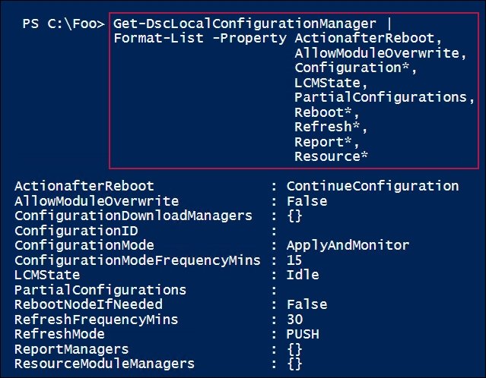

In step 3, you create a configuration statement to configure the LCM of SRV2. There is no output from this step.

In step 4, you execute the configuration to create the MOF file, which looks like this:

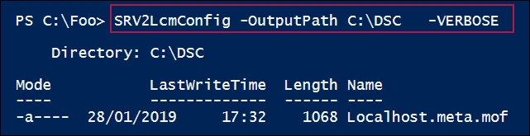

In step 5, you apply the LCM's configuration and, using the -Verbose switch. You get the following output:

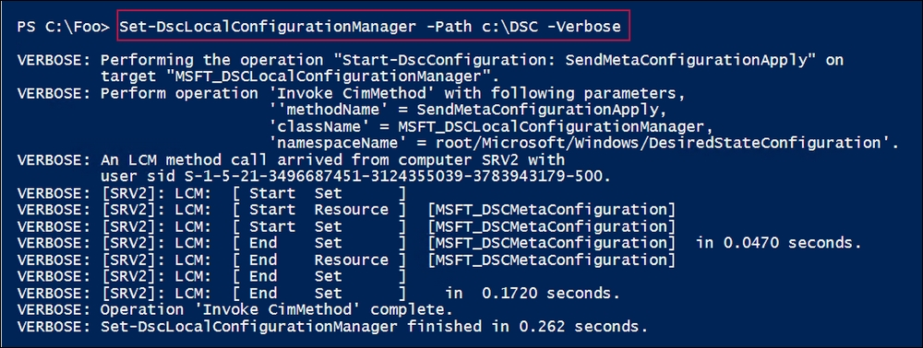

In the final step of this recipe, step 6, you review the key properties of the LCM of SRV2, which looks like this:

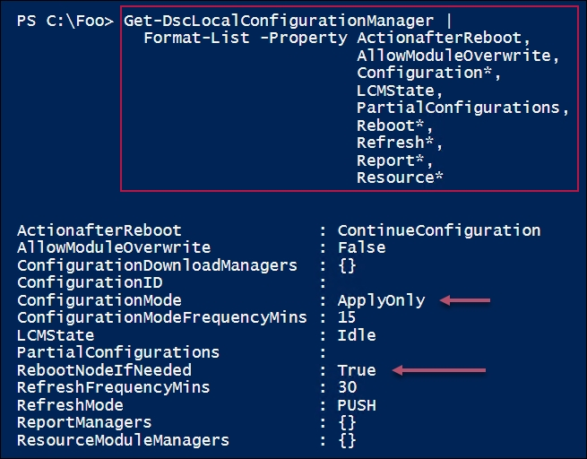

## There's more...

This recipe demonstrated the basics of configuring the LCM on a node. To set up a pull server, as you see in the remaining recipes in this chapter, you need to update the LCM further.

# Implementing an SMB DSC pull server

There are two different types of DSC pull server that you can implement: SMB-based and web-based. The SMB-based pull server approach is most useful on a private routable network, one where all nodes can reach the centralized configuration and resource pull server shares. For high availability, you could set up an SMB pull server on a clustered, scaled-out file server.

DSC uses MOF to communicate the desired state to a node. The LCM on a node, in effect, configures the node based on whatever the MOF file says. MOF files are, at rest, just plaintext documents, and are not encrypted or signed. If your private network is secure, then the SMB pull server is easier to set up and configure. If security is an issue, consider using the web server pull server approach and configure it with HTTPS (which you do in the Implementing a web-based DSC pull server recipe).

Since you may have used other recipes in this chapter—such as the Configuring the DSC local configuration manager recipe where you configured a node—you first need to clean out any existing DSC configuration details before carrying out this recipe.

When you deploy an SMB-based pull server, you place the configuration documents on the SMB share for the target nodes to pull and use. You also configure the LCM on a node to tell the node where and how to get the MOF files. To enable a node to identify which configuration document it should download and use, the node is configured with a GUID (the ConfigurationID) and an SMB share path where the LCM can find configuration MOF files. The MOF file that you deploy to a node is named using the GUID (that is, <guid>.mof).

In this recipe, you configure the LCM on SRV2 with a ConfigurationID set to 5d79ee6e-0420-4c98-9cc3-9f696901a816. The LCM configuration also specifies that the LCM on SRV2 should pull configurations from the SMB pull server located at \\SRV1\DSCConfiguration. In this case, the LCM on SRV2 would look for the file named \\SRV1\DSCConfiguration\5d79ee6e-0420-4c98-9cc3-9f696901a816.mof plus the related checksum file.

This recipe uses another PS Gallery sourced module, the xSMBShare module. This module is used to create a DSC configuration that creates necessary shares. In this case, you use DSC with this module to configure two shares on SRV1, which DSC nodes (that is, SRV2) use to pull configuration documents.

## Getting ready

This recipe is run on SRV1 and provides a DSC configuration for SRV2.

Note

This recipe removes any DSC configuration documents on both SRV1 and SRV2. Any configuration that was performed using previous recipes, for example adding the DNS Server service to SRV2, remain in place with DSC only concerning itself with the new configuration document(s) you add to the pull server.

## How to do it…

1. Ensure that the xSMBShare module is installed on SRV1 and SRV2 and ensure that C:\DSC exists using the following code:

$SB1 = {

Install-Module xSMBShare -Force |

Out-Null

}

Invoke-Command -ComputerName SRV1 -ScriptBlock $SB1

Invoke-Command -ComputerName SRV2 -ScriptBlock $SB1

1. Remove the existing MOF files and DSC configuration on SRV1 and SRV2 using the following code:

$SB2 = {

$RIHT = @{

Path = 'C:\Windows\System32\configuration\*.mof'

ErrorAction = 'SilentlyContinue'

}

Get-Childitem @RIHT |

Remove-Item @RIHT -Force

$EASC = @{

ErrorAction = 'SilentlyContinue'

}

New-Item -Path c:\DSC -ItemType Directory @EASC |

Out-Null

Remove-DscConfigurationDocument -Stage Current

}

Invoke-Command -ComputerName SRV1 -ScriptBlock $SB2

Invoke-Command -ComputerName SRV2 -ScriptBlock $SB2

1. Create a script block to set the LCM configuration for SRV2 that configures SRV2 to pull from SRV1 using the following code:

$SB3 = {

[DSCLocalConfigurationManager()]

Configuration SetSRV2PullMode {

Node localhost {

Settings {

ConfigurationModeFrequencyMins = '30'

ConfigurationMode = 'ApplyAndAutoCorrect'

RebootNodeIfNeeded = $true

ActionAfterReboot = 'ContinueConfiguration'

RefreshMOde = 'Pull'

RefreshFrequencyMins = '30'

AllowModuleOverwrite = $true

ConfigurationID = '5d79ee6e-0420-4c98-'+

'9cc3-9f696901a816'

}

ConfigurationRepositoryShare PullServer {

SourcePath = '\\SRV1\DSCConfiguration'

}

ResourceRepositoryShare ResourceServer {

SourcePath = '\\SRV1\DSCResource'

}

}

}

}

SetSRV2PullMode -OutputPath 'C:\DSC' |

Out-Null

1. Create the MOF file for SRV2 LCM using the following code:

$DHT = @{

Path = 'C:\DSC'

}

Set-DscLocalConfigurationManager -Path C:\DSC

Get-DscLocalConfigurationManager

1. Configure SRV2 to pull via SMB from SRV1 using the following code:

Invoke-Command -ScriptBlock $SB3 -ComputerName SRV2

1. Create a DSC configuration to configure SRV1 as a DSC pull server using the following code:

Configuration PullSrv1

{

Import-DscResource -ModuleName PSDesiredStateConfiguration

Import-DscResource -ModuleName xSmbShare

File ConfigFolder {

DestinationPath = 'C:\DSCConfiguration'

Type = 'Directory'

Ensure = 'Present'

}

File ResourceFolder {

DestinationPath = 'C:\DscResource'

Type = 'Directory'

Ensure = 'Present'

}

xSmbShare DscConfiguration {

Name = 'DSCConfiguration'

Path = 'C:\DscConfiguration\'

DependsOn = '[File]ConfigFolder'

Description = 'DSC Configuration Share'

Ensure = 'Present'

}

xSmbShare DscResource {

Name = 'DSCResource'

Path = 'C:\DscResource'

DependsOn = '[File]ResourceFolder'

Description = 'DSC Resource Share'

Ensure = 'Present' }

}

1. Create a MOF file to configure SRV1 as a pull server using the following code:

PullSRV1 -OutputPath C:\DSC |

Out-Null

1. Use DSC to configure SRV1 as a pull server using the following code:

Start-DscConfiguration -Path C:\DSC -Wait -Verbose -Force

1. Get shares on SRV1 using the following code:

Get-SMBShare -Name DSC*

1. Create a new configuration for SRV2 to pull from SRV1 that configures SRV2 to have a Telnet client feature using the following code:

Configuration TelnetSRV2

{

Import-DscResource –ModuleName 'PSDesiredStateConfiguration'

Node SRV2

{

WindowsFeature TelnetSRV2

{ Name = 'Telnet-Client'

Ensure = 'Present' }

}

}

1. Create a MOF file to configure SRV2 to have the Telnet client using the following code:

TelnetSRV2 -OutputPath C:\DSCConfiguration

1. Rename the MOF file with the GUID name using the following code:

$Guid = '5d79ee6e-0420-4c98-9cc3-9f696901a816'

$RIHT = @{

Path = 'C:\DSCConfiguration\SRV2.mof'

NewName = "C:\DSCConfiguration\$Guid.MOF"

}

Rename-Item @RIHT

1. Create a MOF checksum for the new MOF file using the following code:

New-DscChecksum -Path C:\DSCConfiguration

1. View the MOF and checksum files using the following code:

Get-ChildItem -Path C:\DSCConfiguration

1. View the current configuration on SRV2 using the following code:

Get-WindowsFeature -Name Telnet-Client -ComputerName SRV2

1. Set it to sleep for a while and check it again using the following code:

Start-Sleep -Seconds (30*60)

Get-WindowsFeature -Name Telnet-Client -ComputerName SRV2

## How it works...

In step 1, you ensure that the xSMBShare module is installed on SRV1 and SRV2. In step 2, you remove both any existing MOF files and any DSC configurations from both SRV1 and SRV2. In step 3, you create a script block that creates and deploys an LCM configuration that sets the LCM configuration and creates the related MOF file. These three steps produce no output, although depending on what other recipes you have run, you may get prompted to install the NuGet provider in Step 2.

In step 4, you create a script to run the script block you just created that configures the LCM on SRV2 (based on the configuration block you created in step 3) and returns the LCM configuration, which looks like this:

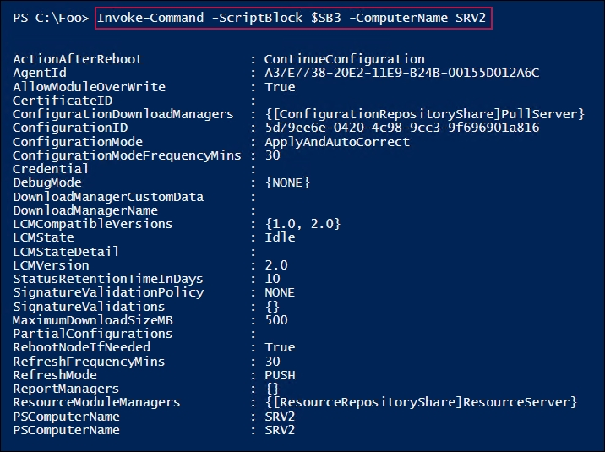

In step 5, you create and compile a configuration statement that configures SRV1 to be a DSC pull server. In step 6, you generate the MOF for this configuration. In step 7, you run the configuration block to produce the relevant MOF file These three steps produce no output.

In step 8, you run Start-DscConfiguration to configure SRV1 based on the just-compiled MOF file, which looks like this:

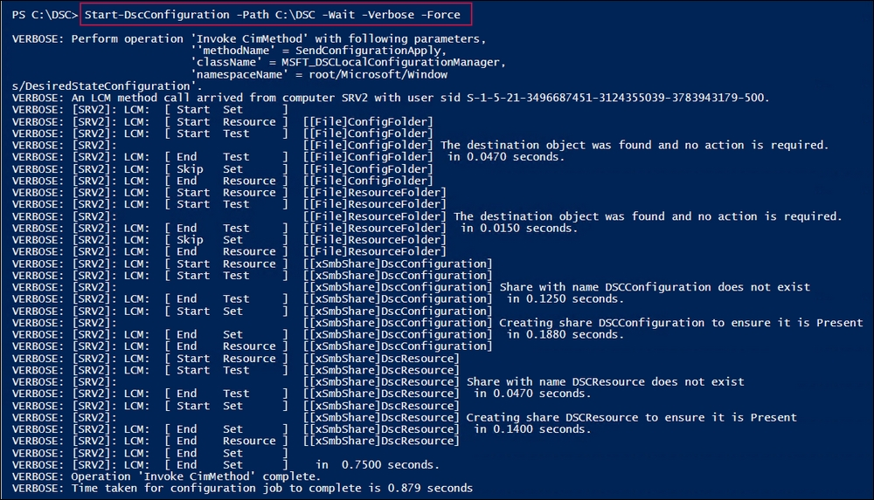

In step 9, you get the SMB shares—created in the previous step—on SRV1, which looks like this:

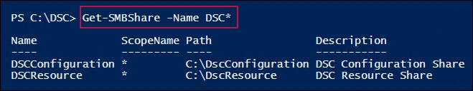

In step 10, you create the first partial configuration block, TelnetSRV2, which creates no output. In step 11, you run this configuration block to produce SRV2.mof, which looks like this:

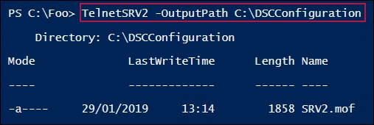

In step 12, you rename the MOF file with the GUID name, and then in step 13, you create a MOF checksum file. These two steps produce no output.

In step 14, you view the MOF and checksum files, which looks like this:

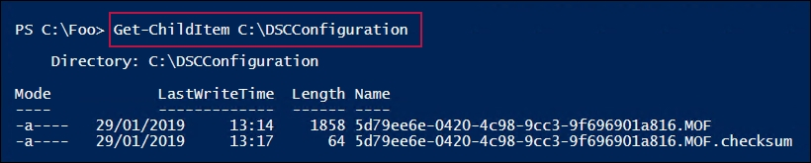

In step 15, you view the current (uninstalled) state of the Telnet-client on SRV2, which looks like this:

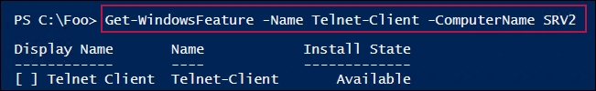

In step 16, you wait for DSC operations to happen, then review the state of Telnet-Client on SRV2, which now looks like this:

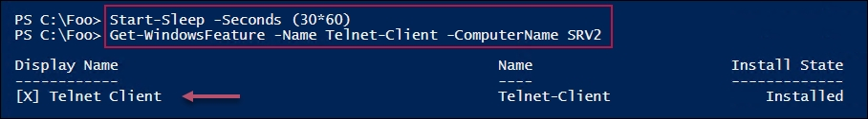

## There's more...

In the last two steps in this recipe, you look at the state of the Telnet client on SRV2. In step 15, you can see that DSC has not yet run the SRV2 configuration, and so the client is not installed. After waiting, in step 16, you can see that the Telnet client is now installed on SRV2. Note that if adding this feature had required a reboot, SRV2 would have been rebooted some time after step 15 completed.

## See also

Setting up a pull server and getting it to configure another server is straightforward, although typos are often a challenge to troubleshoot. By default, Windows Server does not perform detailed DSC event logging; however, it is simple to turn logging on using the following code:

wevtutil.exe set-log "Microsoft-Windows-Dsc/Analytic" /q:true /e:true

wevtutil.exe set-log "Microsoft-Windows-Dsc/Debug" /q:True /e:true

Once you turn on DSC analytic and debug logging, every DSC activity is logged in detail. In earlier recipes, you examined the verbose output of Start-DscConfiguration, which shows the LCM getting and performing a configuration. That same amount of information, and more, is available from the event logs. From these logs, you can trace DSC's activities, see the configuration blocks and resources that are being downloaded, and see DSC enforce the configuration. For more detail on using DSC event logging for troubleshooting, see <https://docs.microsoft.com/powershell/dsc/troubleshooting/troubleshooting>.

# Implementing a web-based DSC pull server

Deploying a DSC web-based pull server is more complex than deploying an SMB pull server. Deploying the SMB-based pull server is simple: just create the two shares that you need and place the relevant files on that share. The web server approach requires you to also load IIS, install the DSC service, and configure the service, as well as place the MOF files, resources, and any relevant checksums on the web server. Of course, in both cases, you need to configure each node's LCM.

You deploy a web-based pull server to provide a pull client with both resources and configuration MOF files. Unlike an SMB-based pull server, a web-based pull server also provides reporting capabilities, enabling a pull client to report the status back to the reporting server.

Reporting is not available using an SMB-based pull server. To simplify the creation of a web-based DSC pull server, you can use the xPSDesiredStateConfiguration module DSC resource. You download this resource from PS Gallery, which greatly simplifies the process of configuring a node to be a DSC pull server (and to be a reporting server).

As with SMB-based pull servers, once you have set up a DSC web pull server, you need to configure the clients to pull configurations/resources from the pull server and send reporting information to the report servers.

The details of setting up a DSC web-based pull server changed with PowerShell V5 (and later versions). This recipe is based on the PowerShell V5 approach.

## Getting ready

This recipe uses two servers: SRV1 and SRV2. SRV1 is the pull server. This recipe configures the DSC web service on SRV1 and configures SRV2 to pull configurations and resources from the pull server.

## How to do it…

1. Install the xPSDesiredStateConfiguration module from the PS Gallery on SRV1 and SRV2 using the following code:

$SB = {

Install-Module -Name xPSDesiredStateConfiguration

}

Invoke-Command -ComputerName SRV1 -ScriptBlock $SB

Invoke-Command -ComputerName SRV2 -ScriptBlock $SB

1. Remove the existing certificates for SRV1, then create a self-signed certificate for SRV1 using the following code:

Get-ChildItem cert:\LocalMachine\root |

Where Subject -EQ 'CN=SRV1.reskit.org' |

Remove-Item -Force

Get-ChildItem cert:\LocalMachine\my |

Where Subject -EQ 'CN=SRV1.reskit.org' |

Remove-Item -Force

$CHT = @{

CertStoreLocation = 'CERT:\LocalMachine\MY'

DnsName = 'SRV1.Reskit.Org'

}

$DscCert = New-SelfSignedCertificate @CHT

1. Copy the certificate to the root store on SRV2 and SRV1 using the following code:

$SB1 = {

Param ($Rootcert)

$C = 'System.Security.Cryptography.X509Certificates.X509Store'

$Store = New-Object -TypeName $C `

-ArgumentList 'Root','LocalMachine'

$Store.Open('ReadWrite')

$Store.Add($Rootcert)

$Store.Close()

}

$ICHT1 = @{

ScriptBlock = $SB1

ComputerName = 'SRV2.Reskit.Org'

Verbose = $True

ArgumentList = $DscCert

}

# run script block on SRV2

Invoke-Command @ICHT1

# and copy it to root on SRV1

$ICHT2= @{

ScriptBlock = $SB1

ComputerName = 'SRV1.Reskit.Org'

Verbose = $True

ArgumentList = $DscCert

}

Invoke-Command @ICHT2

1. Check that the certificate is properly installed on SRV2 using the following code:

$SB2 = {

Get-ChildItem Cert:\LocalMachine\root |

Where-Object Subject -Match 'SRV1.Reskit.Org'

}

Invoke-Command -ScriptBlock $SB2 -ComputerName SRV2

1. Remove the existing DSC configuration on SRV1 and SRV2 using the following code:

$SB3 = {

$RIHT = @{

Path = 'C:\Windows\System32\configuration\*.mof'

ErrorAction = 'SilentlyContinue'

}

Get-Childitem @RIHT |

Remove-Item @RIHT -Force

$EASC = @{

ErrorAction = 'SilentlyContinue'

}

New-Item -Path c:\DSC -ItemType Directory @EASC |

Out-Null

Remove-DscConfigurationDocument -Stage Current

}

Invoke-Command -ComputerName SRV1 -ScriptBlock $SB3

Invoke-Command -ComputerName SRV2 -ScriptBlock $SB3

1. Create a DSC Service Configuration block to make SRV1 a web pull server using the following code:

Configuration WebPullSRV1 {

Param ([String] $CertThumbPrint)

Import-DscResource -Module PSDesiredStateConfiguration

Import-DscResource -Module xPSDesiredStateConfiguration

$Regfile= 'C:\Program Files\WindowsPowerShell\DscService\'+

'RegistrationKeys.txt'

Node SRV1 {

$Key = '5d79ee6e-0420-4c98-9cc3-9f696901a816'

WindowsFeature IIS1 {

Ensure = 'Present'

Name = 'Web-Server'

}

File DSCConfig-Folder {

DestinationPath = 'C:\DSCConfiguration'

Ensure = 'Present'

Type = 'Directory' }

File DSCResource-Folder{

DestinationPath = 'C:\DSCResource'

Ensure = 'Present'

Type = 'Directory' }

WindowsFeature DSCService {

DependsOn = '[WindowsFeature]IIS1'

Ensure = 'Present'

Name = 'DSC-Service' }

xDscWebService WebPullSRV1 {

Ensure = 'Present'

EndpointName = 'PSDSCPullServer'

Port = 8080

PhysicalPath = 'C:\inetpub\PSDSCPullServer'

CertificateThumbPrint = $CertThumbPrint

ConfigurationPath = 'C:\DSCConfiguration'

ModulePath = 'C:\DSCResource'

State = 'Started'

UseSecurityBestPractices = $true

DependsOn =

'[WindowsFeature]DSCService','[WindowsFeature]IIS1'

}

File RegistrationKeyFile {

Ensure = 'Present'

Type = 'File'

DestinationPath = $Regfile

Contents = $Key }

} # End of Node configuration

} # End of Configuration

1. Create a MOF file to configure SRV1 using the following code:

$TP = $DscCert.Thumbprint

WebPullSRV1 -OutputPath C:\DSC -CertThumbPrint $TP |

Out-Null

1. Use DSC to configure SRV1 to host the DSC web service using the following code:

Start-DscConfiguration -Path C:\DSC -Wait -Verbose

$DscCert | Set-Item -Path IIS:\SslBindings\0.0.0.0!8080

1. Check on the results using the following code:

$URI = 'https://SRV1.reskit.org:8080/PSDSCPullServer.svc/'

Start-Process -FilePath $URI

1. Create a metaconfiguration to make SRV2 pull two partial configuration blocks from SRV1 using the following code:

[DSCLocalConfigurationManager()]

Configuration SRV2WebPullPartial {

Node SRV2 {

Settings {

RefreshMode = 'Pull'

ConfigurationModeFrequencyMins = 30

ConfigurationMode = 'ApplyandAutoCorrect'

RefreshFrequencyMins = 30

RebootNodeIfNeeded = $true

AllowModuleOverwrite = $true

}

ConfigurationRepositoryWeb DSCPullSrv {

ServerURL = 'https://SRV1.Reskit.Org:8080/PSDSCPullServer.svc'

RegistrationKey = '5d79ee6e-0420-4c98-9cc3-9f696901a816'

ConfigurationNames = @('NFSConfig','SMBConfig')

}

PartialConfiguration NFSConfig {

Description = 'NFS Client Configuration'Configurationsource =@('[ConfigurationRepositoryWeb]DSCPullSrv')

}

PartialConfiguration SMBConfig {

Description = 'FS-SMB1 Client Removal'

Configurationsource = @('[ConfigurationRepositoryWeb]DSCPullSrv')

DependsOn = '[PartialConfiguration]NFSConfig'}

}

} # End of Configuration block

1. Create a MOF to configure DSC LCM on SRV2 using the following code:

SRV2WebPullPartial -OutputPath C:\DSC | Out-Null

1. Configure LCM on SRV2 using the following code:

$CSSrv2 = New-CimSession -ComputerName SRV2

$LCMHT = @{

CimSession = $CSSrv2

Path = 'C:\DSC'

Verbose = $true

}

Set-DscLocalConfigurationManager @LCMHT

1. Create a partial configuration to ensure that the NFS client is present using the following code:

Configuration TFTPSRV2 {

Import-DscResource –ModuleName 'PSDesiredStateConfiguration'

Node SRV2 {

WindowsFeature TFTPClient {

Name = 'TFTP-Client'

Ensure = 'Present'

}

}

}

1. Create the MOF file for this configuration and place the MOF file into the configuration folder using the following code:

Remove-Item -Path C:\DSCConfiguration -Rec -Force

TFTPSRV2 -OutputPath C:\DSCConfiguration |

Out-Null

1. Rename the file and create the checksum using the following code:

$RIHT = @{

Path = 'C:\DSCConfiguration\SRV2.mof'

NewName = "C:\DSCConfiguration\$Guid.MOF"

}

Rename-Item @RIHT

New-DscChecksum -Path C:\DSCConfiguration

Get-ChildItem C:\DSCConfiguration

1. Wait a while, then review the details using the following code:

Start-Sleep -Seconds (30*60)

$Session = New-CimSession -ComputerName SRV2

Get-DscConfiguration -CimSession $Session

1. Check on the feature on SRV2 using the following code:

Get-WindowsFeature -Name TFTP-Client -ComputerName SRV2

## How it works...

In step 1, you ensure that the xDesiredStateConfiguration module is loaded on both SRV1 and SRV2. In step 2, you remove the existing certificates for SRV1 then create a new self-signed certificate. In step 3, you copy the newly created self-signed certificate to the root store of SRV2, thereby enabling SRV2 to trust the self-signed certificate. These three steps produce no output.

In step 4, you check to ensure that the certificate is properly installed on SRV2, which looks like this:

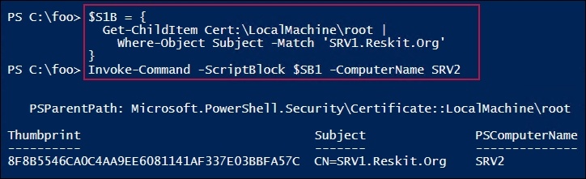

In step 5, you forcibly remove any DSC configuration information from both SRV1 and SRV2. In step 6, you create a configuration to configure SRV1. Then, in step 7, you run the configuration to produce the MOF file to configure SRV1 to be a pull. These three steps produce no output.

In step 8, you use the Start-DscConfiguration cmdlet to set the DSC configuration for SRV1, which looks like this:

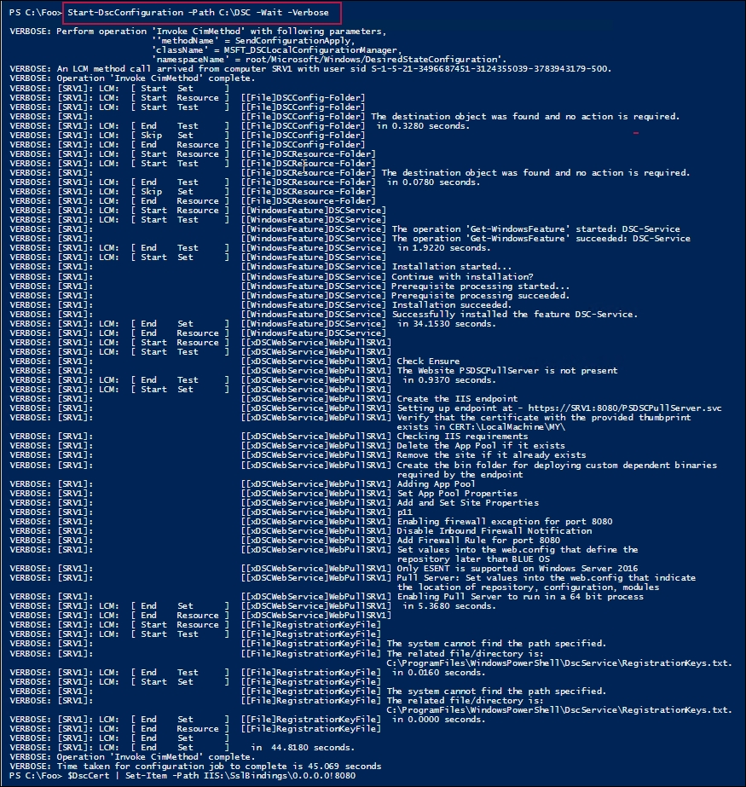

In step 9, you use the browser to check on the configuration of SRV1 as a DSC pull server, which looks like this:

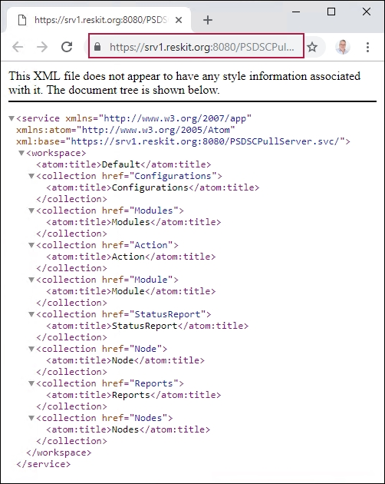

In step 10, you create an LCM configuration document to make SRV2 pull DSC partial configurations from SRV1 via HTTPS. In step 11, you use the configuration statement to create the required MOF file. These two steps produce no output.

In step 12, you use Set-DSCLocalConfigurationManager to configure the LCM on SRV2. The output from this step, created by using the -Verbose and -Wait switches, looks like this:

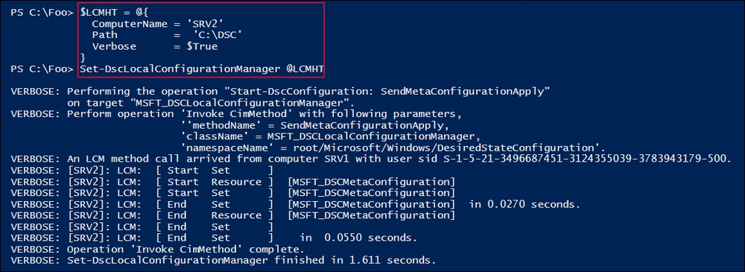

In step 13, you create a partial configuration to ensure that the NFS client is present, and then in step 14, you run the configuration to create the MOF file. You send the MOF file to the C:\DSCConfiguration folder. There is no output from these two steps.

In step 15, you rename the MOF file, create the DSC checksum file, and view the contents of the DSCConfiguration folder, which looks like this:

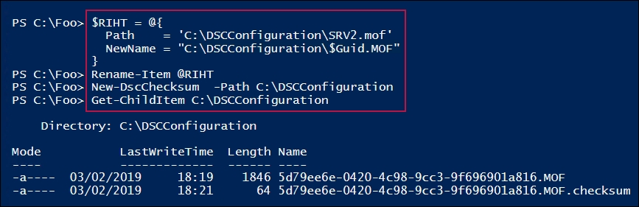

In step 16, you wait for SRV2 to contact SRV1, and then pull the configuration and apply it. Then you can get the DSC configuration for SRV2, which looks like this.

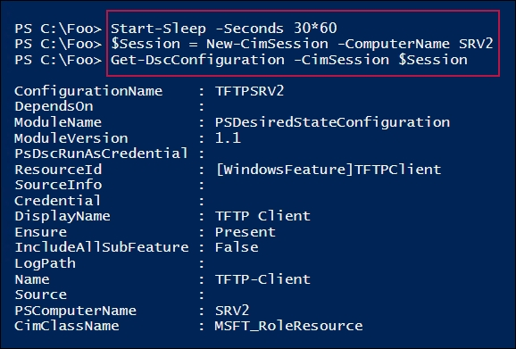

In step 17, you check for the presence of the TFTP client on SRV2, which looks like this:

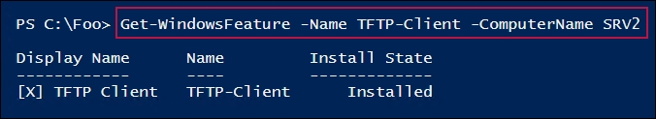

## There's more...

In step 5, you remove all DSC configurations from both SRV1 and SRV2. After doing that, running some of the DSC cmdlets, such as Get-DSCConfiguration, may result in an error, as there is no configuration. This error is to be expected. In later steps in the recipe, you push a configuration to SRV1 and enable SRV2 to pull its configuration from the DSC pull server on SRV1. Once those steps are complete (and SRV2 gets around to pulling the two partial configurations from SRV1), the DSC cmdlets work as expected. Also, if you examine the DSC event logs, events happening just after you wipe the DSC configuration can show odd dates and times in the event log entries. This is also to be expected.

In step 9, you viewed the output from the SRV1's DSC web service over HTTPS. If the system you run this step on trusts the certificate, you see the page as shown. If, for some reason, you have not copied the self-signed certificate in the local machine's root certificate store, you see certificate errors when navigating to the DSC service.

If you run the step on another computer, say DC1, then you see a certificate error, since that computer does not trust the self-signed certificate.

# Using DSC partial configurations

PowerShell V5 introduced a new extension to DSC known as partial configurations. A partial configuration is a DSC configuration that makes up part of a given node's overall desired state. Each node can then pull (and apply) some or all of those partial configurations.

Partial configurations allow you to share the configuration of a node between multiple teams. For example, you might want the central IT team to define the basic configuration of a node. Another team could be responsible for deploying a web application to that same node. The alternative is to have a single MOF document fully describing a node's desired state, which can be organizationally challenging.

To support partial configurations, you configure a node's LCM to define the partial configurations that the node should pull and how the node is to be configured. Each partial configuration can be either pushed or pulled as appropriate. This provides considerable flexibility in deploying DSC partial configurations.

In this recipe, you configure SRV2 to pull two partial configurations from SRV1.

## Getting ready

In this recipe, you use two servers, SRV1 and SRV2, which you used in the other recipes in this chapter.

## How to do it…

1. Remove the existing certificates for SRV1, then create a self-signed certificate for the FQDN SRV1.Reskit.Org using the following code:

Get-ChildItem Cert:\LocalMachine\root |

Where Subject -EQ 'CN=SRV1.Reskit.Org' |

Remove-Item -Force

Get-ChildItem Cert:\LocalMachine\my |

Where Subject -EQ 'CN=SRV1.Reskit.Org' |

Remove-Item -Force

$CHT = @{

CertStoreLocation = 'Cert:\LocalMachine\MY'

DnsName = 'SRV1.Reskit.Org'

}

$DscCert = New-SelfSignedCertificate @CHT

1. Copy the certificate to the root store on SRV2 and SRV1 using the following code:

$SB1 = {

Param ($Rootcert)

$C = 'System.Security.Cryptography.X509Certificates.X509Store'

$Store = New-Object -TypeName $C `

-ArgumentList 'Root','LocalMachine'

$Store.Open('ReadWrite')

$Store.Add($Rootcert)

$Store.Close()

}

$ICHT1 = @{

ScriptBlock = $SB1

ComputerName = 'SRV2.Reskit.Org'

Verbose = $True

ArgumentList = $DscCert

}

# run script block on SRV2

Invoke-Command @ICHT1

# and copy it to root on SRV1

$ICHT3= @{

ScriptBlock = $SB1

ComputerName = 'SRV1.Reskit.Org'

Verbose = $True

ArgumentList = $DscCert

}

Invoke-Command @ICHT3

1. Check the certificate in the root certificate store on SRV2 using the following code:

$SB2 = {

Get-ChildItem Cert:\LocalMachine\root |

Where-Object Subject -Match 'SRV1.Reskit.Org'

}

Invoke-Command -ScriptBlock $SB2 -ComputerName SRV2

1. Remove the existing DSC configuration on SRV1 and SRV2 using the following code:

$SB3 = {

$RIHT = @{

Path = 'C:\Windows\System32\configuration\*.mof'

ErrorAction = 'SilentlyContinue'

}

Get-Childitem @RIHT |

Remove-Item @RIHT -Force

$EASC = @{

ErrorAction = 'SilentlyContinue'

}

New-Item -Path c:\DSC -ItemType Directory @EASC |

Out-Null

Remove-DscConfigurationDocument -Stage Current

}

Invoke-Command -ComputerName SRV1 -ScriptBlock $SB3

Invoke-Command -ComputerName SRV2 -ScriptBlock $SB3

1. Ensure that the xPsDesiredStateConfiguration module is installed on both SRV1 and SRV2 using the following code:

$SB2 = {

Install-Module -Name xPSDesiredStateConfiguration -Force

}

Invoke-Command -Computer SRV1 -ScriptBlock $SB2

Invoke-Command -Computer SRV2 -ScriptBlock $SB2

1. Create the desired state configuration for SRV1 using the following code:

Configuration WebPullSrv1 {

Param ([String] $CertThumbPrint)

Import-DscResource -Module PSDesiredStateConfiguration

Import-DscResource -Module xPSDesiredStateConfiguration

$Regfile= 'C:\Program Files\WindowsPowerShell\DscService\'+

'RegistrationKeys.txt'

Node SRV1 {

$Key = '5d79ee6e-0420-4c98-9cc3-9f696901a816'

WindowsFeature IIS1 {

Ensure = 'Present'

Name = 'Web-Server'

}

File DSCConfig-Folder {

DestinationPath = 'C:\DSCConfiguration'

Ensure = 'Present'

Type = 'Directory'

}

File DSCResource-Folder{

DestinationPath = 'C:\DSCResource'

Ensure = 'Present'

Type = 'Directory'

}

WindowsFeature DSCService {

DependsOn = '[WindowsFeature]IIS1'

Ensure = 'Present'

Name = 'DSC-Service'

}

xDscWebService WebPullSRV1 {

Ensure = 'Present'

EndpointName = 'PSDSCPullServer'

Port = 8080

PhysicalPath = 'C:\inetpub\PSDSCPullServer'

CertificateThumbPrint = $CertThumbPrint

ConfigurationPath = 'C:\DSCConfiguration'

ModulePath = 'C:\DSCResource'

State = 'Started'

UseSecurityBestPractices = $true

DependsOn =

'[WindowsFeature]DSCService','[WindowsFeature]IIS1'}

File RegistrationKeyFile {

Ensure = 'Present'

Type = 'File'

DestinationPath = $Regfile

Contents = $Key }

} # End of Node configuration

} # End of Configuration

1. Remove any existing MOF files on SRV1, then create an MOF file for SRV1 using the following code:

Get-ChildItem -Path C:\DSC -ErrorAction SilentlyContinue |

Remove-Item -Force | Out-Null

$TP = $DscCert.Thumbprint

WebPullSrv1 -OutputPath C:\DSC -CertThumbPrint $TP

1. Configure SRV1 to host the DSC web service using the following code:

Start-DscConfiguration -Path C:\DSC -Wait -Verbose

$DscCert | Set-Item -Path IIS:\SslBindings\0.0.0.0!8080

1. Check on the results using the browser with the following code:

$URI = 'https://SRV1.reskit.org:8080/PSDSCPullServer.svc/'

Start-Process -FilePath $URI

1. Create a metaconfiguration to make SRV2 pull two partial configuration blocks from SRV1 using the following code:

[DSCLocalConfigurationManager()]

Configuration SRV2WebPullPartial {

Node SRV2 {

Settings

{ RefreshMode = 'Pull'

ConfigurationModeFrequencyMins = 30

ConfigurationMode = 'ApplyandAutoCorrect'

RefreshFrequencyMins = 30

RebootNodeIfNeeded = $true

AllowModuleOverwrite = $true }

ConfigurationRepositoryWeb DSCPullSrv {

ServerURL = 'HTTPS://SRV1.Reskit.Org:8080/PSDSCPullServer.svc'

RegistrationKey = '5d79ee6e-0420-4c98-9cc3-9f696901a816'

ConfigurationNames = @('NFSConfig','SMBConfig') }

PartialConfiguration NFSConfig {

Description = 'NFS Client Configuration'

Configurationsource =

@('[ConfigurationRepositoryWeb]DSCPullSrv')}

PartialConfiguration SMBConfig {

Description = 'FS-SMB1 Client Removal'

Configurationsource =

@('[ConfigurationRepositoryWeb]DSCPullSrv')

DependsOn = '[PartialConfiguration]NFSConfig'

}

} # End Node 2 Configuration

}

1. Run the configuration to create the MOF file to configure DSC LCM on SRV2 using the following code:

SRV2WebPullPartial -OutputPath C:\DSC | Out-Null

1. Configure the LCM on SRV2 with the updated configuration using the following code:

$CSSrv2 = New-CimSession -ComputerName SRV2

$LCMHT = @{

CimSession = $CSSrv2

Path = 'C:\DSC'

Verbose = $true

}

Set-DscLocalConfigurationManager @LCMHT

1. Create the NFS client partial configuration and related build MOF file, then rename the partial configuration using the following code:

$Guid = '5d79ee6e-0420-4c98-9cc3-9f696901a816'

$ConfigData = @{

AllNodes = @(

@{ NodeName = '*' ; PsDscAllowPlainTextPassword = $true},

@{ NodeName = $Guid }

)

}

Configuration NFSConfig {

Import-DscResource –ModuleName PSDesiredStateConfiguration

Node $Allnodes.NodeName {

WindowsFeature NFSClientPresent {

Name = 'NFS-Client'

Ensure = 'Present'

}

}

}

$CHT1 = @{

ConfigurationData = $ConfigData

OutputPath = 'C:\DSCConfiguration'

}

NFSConfig @CHT1

$RIHT = @{

Path = "C:\DSCConfiguration\$Guid.mof"

Newname = 'C:\DSCConfiguration\NFSConfig.MOF'

}

Rename-Item @RIHT

1. Create and compile the SMB client partial configuration, which ensures that SMB is not installed, using the following code:

$Guid = '5d79ee6e-0420-4c98-9cc3-9f696901a816'

$ConfigData = @{

AllNodes = @(

@{ NodeName = '*' ; PsDscAllowPlainTextPassword = $true},

@{ NodeName = $Guid }

)

}

Configuration SMBConfig {

Import-DscResource –ModuleName 'PSDesiredStateConfiguration'

Node $AllNodes.NodeName {

WindowsFeature SMB1 {

Name = 'FS-SMB1'

Ensure = 'Absent'

}

}

}

$SMBHT = @{

ConfigurationData = $ConfigData

OutputPath = 'C:\DSCConfiguration\'

}

SMBConfig @SMBHT | Out-Null

$RIHT = @{

Path = "C:\DSCConfiguration\$Guid.mof"

NewName = 'C:\DSCConfiguration\SMBConfig.MOF'

}

Rename-Item @RIHT

1. Create DSC checksums for the two partial configurations using the following code:

New-DscChecksum -Path C:\DSCConfiguration

1. Observe the configuration documents and checksum using the following code:

Get-ChildItem -Path C:\DSCConfiguration

1. Wait, then check the status of the features on SRV2 using the following code:

Start-Sleep -Seconds (30*60) # wait for 30 minutes

$FeatureNames = @('FS-SMB1', 'NFS-Client')

Get-WindowsFeature -ComputerName SRV2 -Name $FeatureNames

1. Test the DSC configuration for SRV2 using the following code:

Test-DscConfiguration -ComputerName SRV2 -Verbose

## How it works…

In step 1, you remove any existing certificates for SRV1.Reskit.Org, then you create a new self-signed certificate that you store in the local machine's MY certificate store. In step 2, you copy that certificate to the local machine's ROOT certificate store on SRV1 and SRV2. These two steps produce no output.

In step 3, you examine the certificate in the local machine's ROOT certificate store on SRV2, which looks like this:

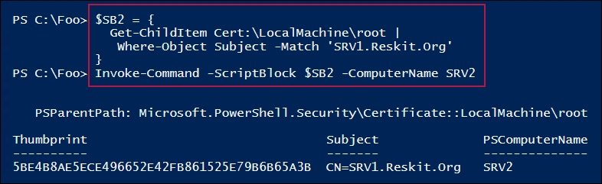

In step 4, you remove all DSC configurations from both SRV1 and SRV2. In step 5, you ensure that the xPsDesiredStateConfiguration module is installed on both SRV1 and SRV2. In step 6, you create a DSC Configuration block for SRV1. These three steps produce no output.

In step 7, you remove any old MOF files in C:\DSC on SRV1, then create the MOF file to configure SRV1 to be a pull server. This step produces output like this:

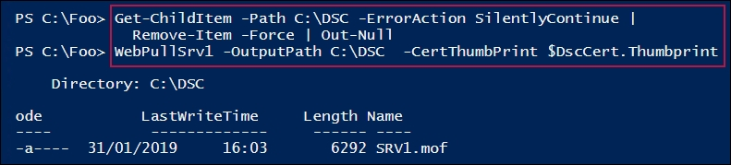

In step 8, you use Start-DSCConfiguration to configure SRV1 to be a pull server. This produces output like this:

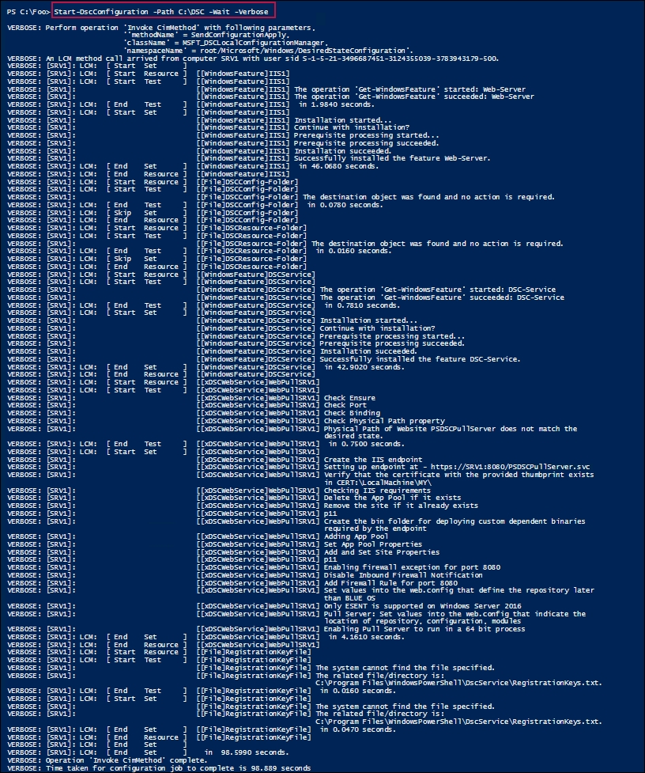

In step 9, you check to see whether the DSC web-based pull service is running on SRV1, which looks like this:

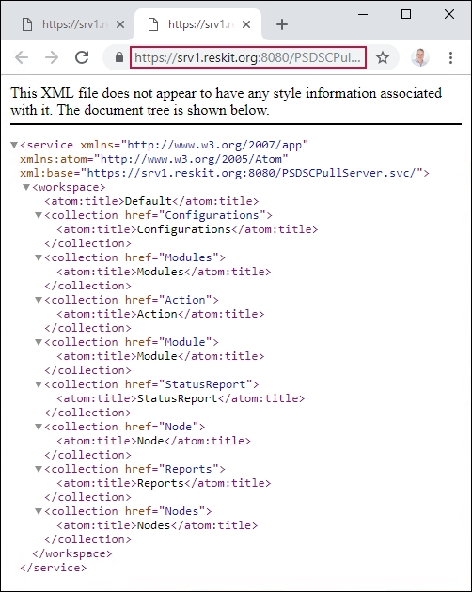

In step 10, you create a metaconfiguration to make SRV2 pull two partial configuration blocks from SRV1. In step 11, you create the MOF file for SRV2. These steps produce no output.

In step 12, you configure SRV2 to pull partial configurations from SRV1, which looks like this:

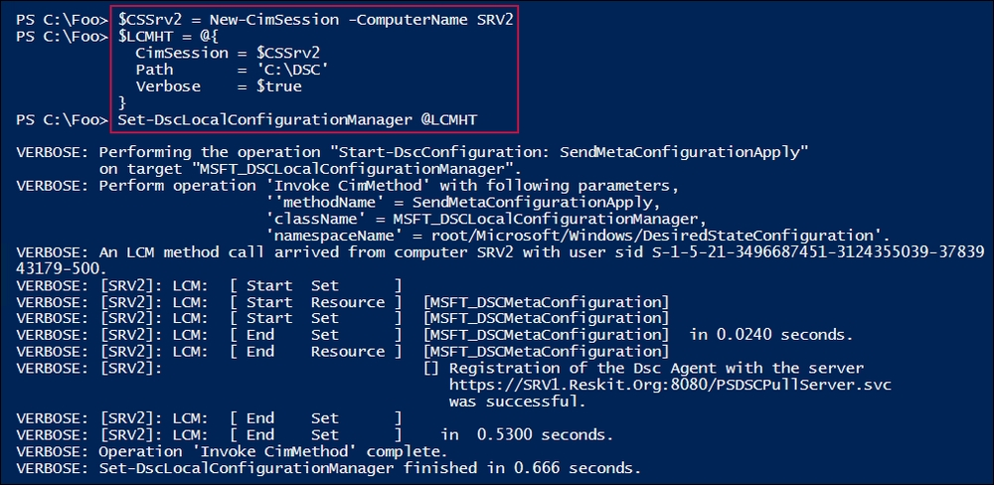

In step 13, you create a partial configuration to install the NSF client. In step 14, you create and compile another partial configuration to ensure that SMB1 is absent. In step 15, you create DSC checksum files for these two configurations. These three steps produce no output.

In step 16, you examine the configuration information available in the C:\DSCConfiguration folder (which is now available to nodes via the DSC pull service). The output looks like this:

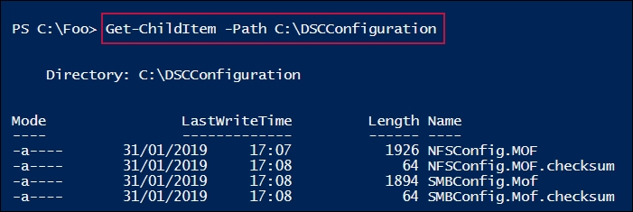

Once you have completed deploying the partial configurations, you wait for the LCM in SRV2 to recheck its configuration and deploy the two partial configurations. In step 18, you examine the state of the two features on SRV2 (now configured as per the partial configurations), which looks like this:

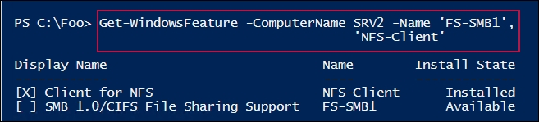

In step 18, you test the DSC configuration on SRV2 (to see whether the node is in the desired state), which looks like this:

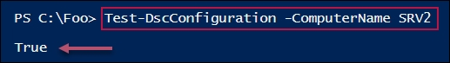

## There's more...

In step 1, you create a self-signed certificate that you make trusted on SRV1, and in step 2, you make this certificate trusted on SRV2. In an ideal world, you should create an enterprise certificate authority (CA), then issue certificates signed by that CA. With an enterprise CA, your root certificates can be autopublished, making the SRV1 server's certificate trusted by everyone.

In step 2, you use .NET to copy the certificate to SRV2. The certificate provider in PowerShell does not support a copy operation, allowing you to use Copy-Item to copy the certificate between certificate stores on SRV1 and SRV2. But .NET provides a mechanism to copy the certificate to SRV2.

With step 3, you view the certificate contained in the SRV2 server's local machine's trusted root certificate store. Note that the thumbprint is the same as the thumbprint shown in step 2. In effect, what you have done is to make the certificate in the local machine's personal certificate store trusted on SRV2 (and, using step 1, on SRV1).

Note that you could set DSC up to not use SSL (and therefore require certificates). This is, in general, not a good idea as it does not protect us from a man-in-the-middle attack. It also means that the MOF documents transmitted from a pull server are in plain text. For configurations that contain credentials or other internal secrets, the best practice is to use SSL.

In step 5, you ensure that the DSC resources that you need (which are contained in the (xPSDesiredStateConfiguration module) have been copied to SRV2. You could also have placed it on the pull server (SRV1) to enable the pull client to download it. This is probably a better approach for production use—just put all the resources in one place, and let the nodes pull that module when necessary.

In step 17, you check that DSC has configured SRV2. Depending on how long you take between step 16 and step 17, you may not see SRV2 being in the desired state. As was the case in the Implementing a web-based DSC pull server recipe, you need to wait until the LCM in SRV2 checks the consistency (and applies the partial configurations). One way to speed this up would be to reboot SRV2 after step 16. After the reboot, SRV2 would check for DSC consistency without waiting.